

DEPARTMENT OF COMPUTER SCIENCE & ENGINEERING

**CS451 & SEMINAR AND PROJECT**

**PRELIMINARY**

Zeroth Review

Date:

Contents

● Team and Guide Details

● Problem Statement

● Existing solutions (if any)

● Proposed method

● Technique/Technology going to Apply

● Gantt chart

● References

Department of Computer Science and Engineering

Team and Guide Details

Project Name

**TeachAR**

Team Members

● Christy Varghese

● Amal Anto

● Hanna Elsa Reni George

● Jiya George

Guide Name

Mr.Bino Thomas

Department of Computer Science and Engineering

Problem Statement

Since the COVID -19 pandemic has disrupted the normal lifestyle of people across the globe, the virtual world has come to the rescue. Amongst many institutions schools have also shifted their base to virtual platforms to conduct classes online. But recent studies show that this virtual method is not as effective as the traditional education system since students are not able to fully understand the idea or concept. Hence both the teachers and students are struggling a lot, especially when it comes to explaining the structure of different objects which these students might not have seen before (for example, the structure of molecules, cells, 3D figures etc.)

Department of Computer Science and Engineering

Existing solutions (if any)

● TutAR-Next reality classroom

● Augmented Class

● Math alive

● Elements 4D

Department of Computer Science and Engineering

Proposed method

● AR classroom for students and teachers.

● 3D models of various figures.

● Screen sharing with students

● The chapters in the app will be based on the syllabus of the Kerala State Education Board

● Allows students to ask doubts and interact with the teachers.

● Allows teachers to present their screens and explain the concepts by showing the 3D model

Department of Computer Science and Engineering

Technique/Technology going to apply

● Augmented Reality- An enhanced version of reality created by the use of technology to overlay digital information on an image of something being viewed through a device (such as a smartphone camera).

● 3D modelling- is the creation of 3D images of different objects, where it is mathematically represented in three dimensions.

● Texting- act of sending short messages with cell phones, usually using the Short Messaging Service (SMS).

● Videophony- technology for the reception and transmission of audio-video signals by users at different locations, for communication between people in real time.

Department of Computer Science and Engineering 

Gantt chart

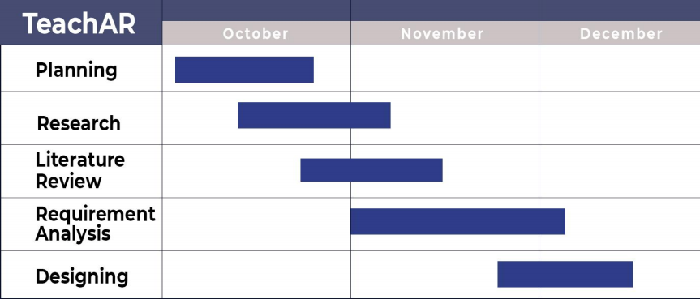Department of Computer Science and Engineering

References

● https://infusory.in/interactive-learning-through-ar-next-reality-classroom/ ● https://www.edutopia.org/blog/ar-apps-for-student-learning-monica-burns ● https://play.google.com/store/apps/details?id=com.AugmentedClass.AClass&h l=en_IN&gl=US

● https://alivestudiosco.com/math-alive-kit/

Department of Computer Science and Engineering

**Thank You**

Department of Computer Science and Engineering